# Translating Portuguese

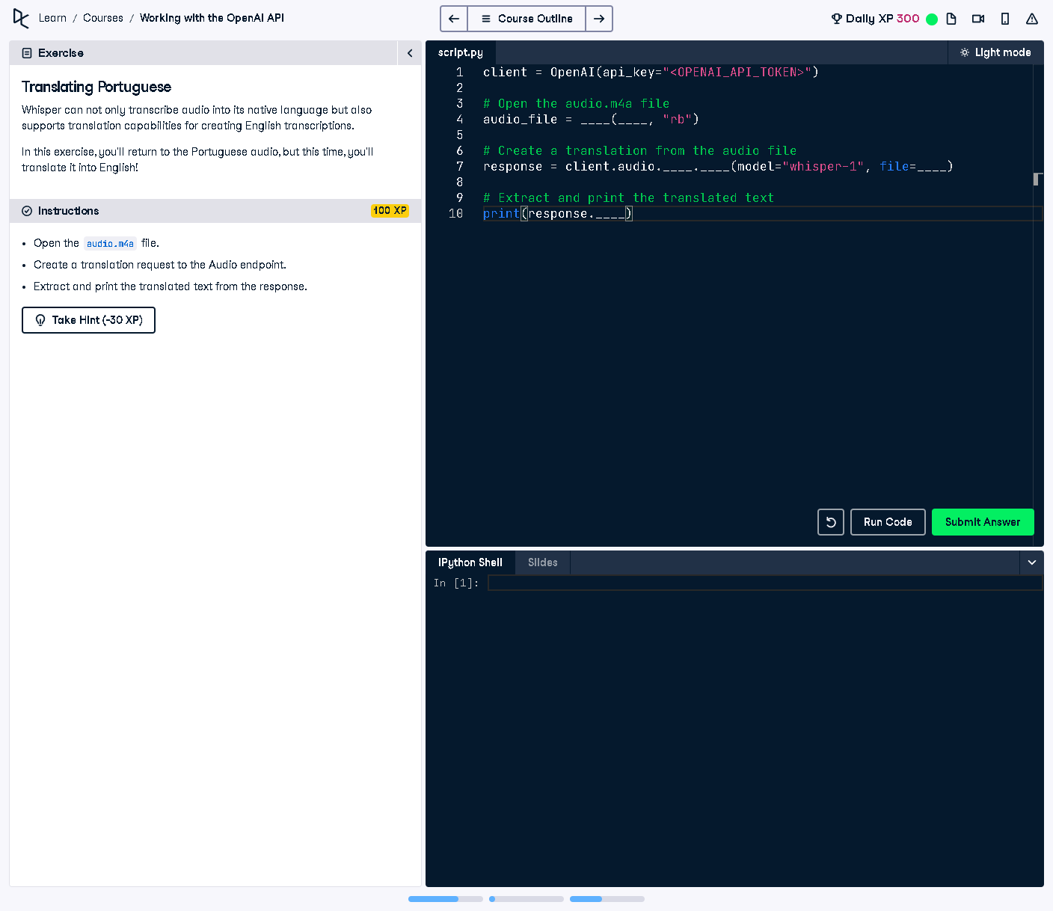

## Question:

Whisper can transcribe audio and translate it into English. In this exercise, we are provided with a Portuguese audio file, and we need to use OpenAI’s API to translate its content into English.

## Explanation:

The given task requires using OpenAI’s Whisper API to process a Portuguese audio file. The goal is to open the audio file, create a translation request, and extract the translated text. This involves initializing the OpenAI client, loading the audio, and making an API call.

## Answer:

from openai import OpenAI  
  
# Initialize the OpenAI client with the API key  
client = OpenAI(api_key="YOUR_OPENAI_API_KEY")  
  
# Open the audio.m4a file in binary mode  
audio_file = open("audio.m4a", "rb")  
  
# Create a translation request to OpenAI's Whisper API  
response = client.audio.translate(model="whisper-1", file=audio_file)  
  
# Extract and print the translated text from the response  
print(response["text"])

## Explanation of the Code:

1. The OpenAI client is initialized with an API key.  
2. The audio file ('audio.m4a') is opened in binary mode for reading.  
3. The `client.audio.translate` function is used with model='whisper-1' to process the file.  
4. The API response contains the translated text, which is extracted and printed.  
5. The output will be the English translation of the Portuguese audio.